# Trading Bot using Donchian Channels Strategy

## Importing the Data and Indicators

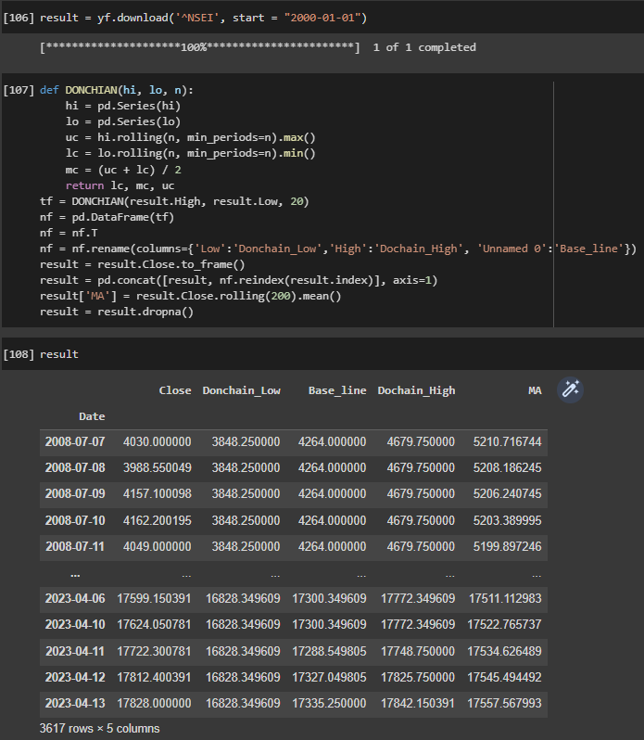

## Plotting the Close Price with Indicators

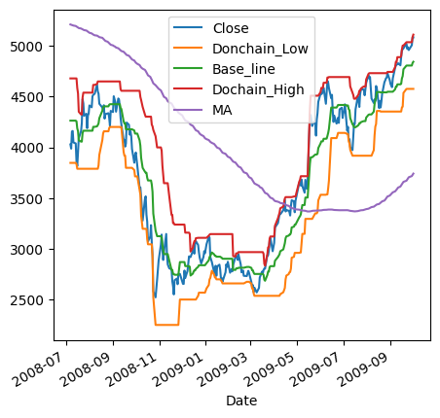

## Creating Buy and Sell Signals

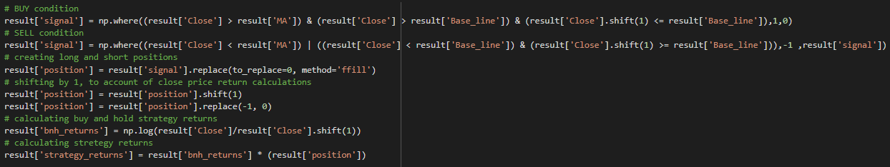

## Plotting the Positions

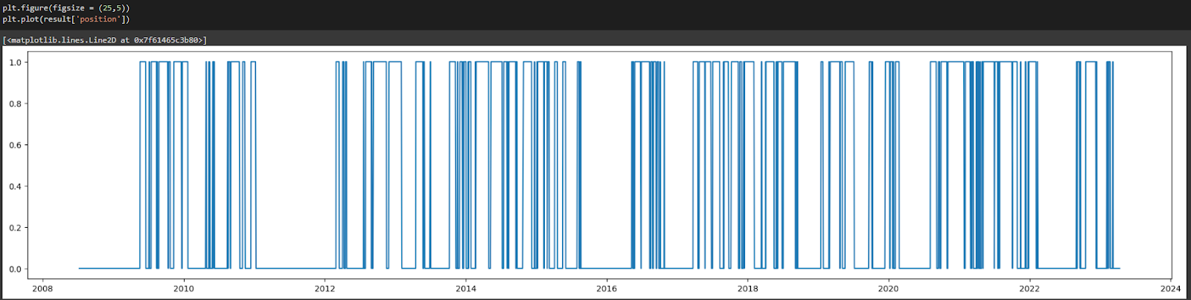

## Backtesting and Plotting the Results

